Supplementary material

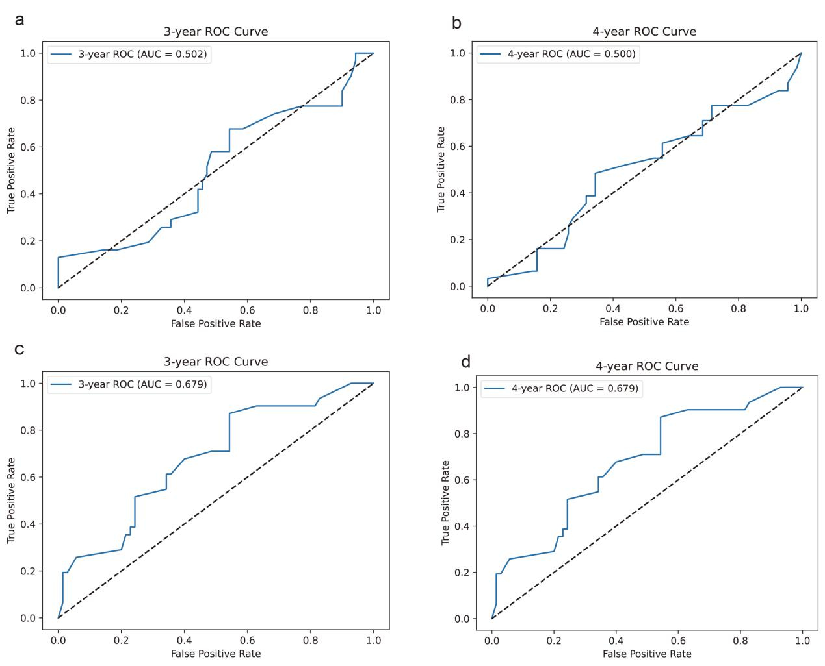
Supplementary Fig. 1. Predictive performance evaluation of DeepHit and Cox proportional hazards models. (a) Time-dependent Receiver Operating Characteristic (ROC) curve for the DeepHit model at 3 year. (b) ROC curve for the DeepHit model at 4 years. (c) ROC curve for the Cox model at 3 year. (d) ROC curve for the Cox model at 4 years. In panels a–d, the dashed diagonal line indicates the reference line of no discrimination. AUC: Area Under the Curve.

